UW researchers and Florida middle school students form unusual bond over cosmic kidney stones
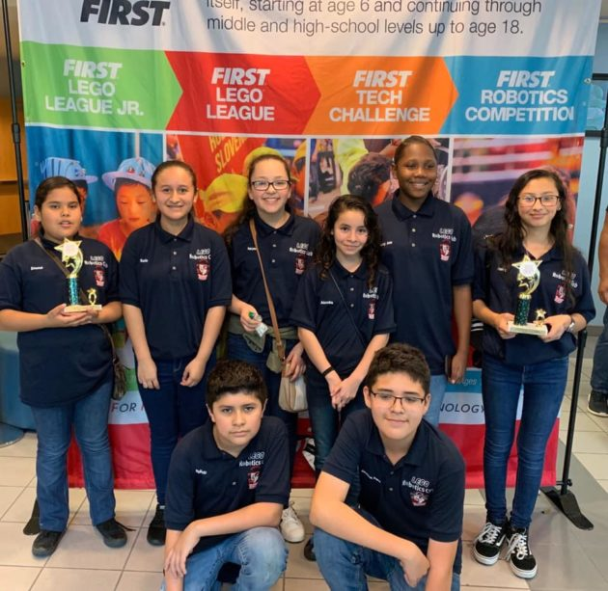
BY KELLIE SCHMITT on February 23, 2019 at 6:00 am
A collaboration between this Florida middle school robotics team and the University of Washington is potentially “life changing,” according to a science teacher at the school. (Pahokee Middle School Photo)
Eight students from a low-income sugarcane town in South Florida spent months on a robotics project tackling kidney stones in space.
Across the country, researchers at the University of Washington were studying the exact problem for NASA, embarking on clinical trials that, so far, are proving successful.
The disparate groups converged this month when the students reached out to UW physicist and research professor Lawrence Crum as part of the competition’s requirement to seek expert input. Crum responded with a comprehensive letter back to the students that expressed his admiration for their ideas. Amid the various student projects he’s seen in his career, Crum told GeekWire that “these kids from a Title 1 school in Florida are close to the best I’ve seen.”
The students from Pahokee Middle School will put their knowledge to the test this weekend at a regional robotics competition in Palm Beach County, with the goal of making it to the national level for the second year in a row. For the students, many who have parents working in sugarcane fields, the dialogue with UW experts is potentially life changing, said robotics team co-coach Brad Sokol, a retired entrepreneur who is now a science teacher at Pahokee Middle School.
“When you come from a community like this, where every day is survival, this is so incredible,” Sokol said.
The unusual collaboration has even captured the attention of NASA. “This research can help to answer fundamental questions about how NASA manages kidney stones in space,” said element scientist Dr. Kris Lehnhardt.

Pahokee’s path
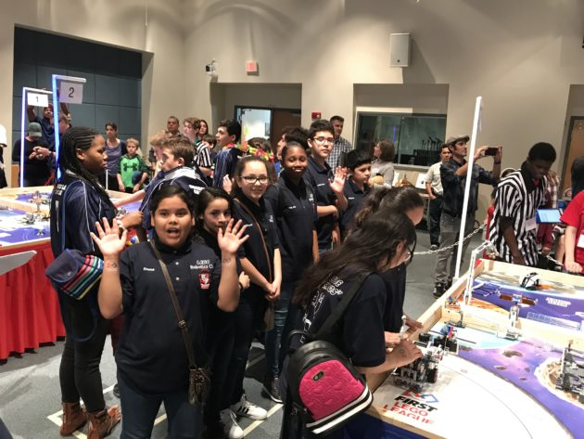The students from Pahokee Middle School will put their knowledge to the test this weekend at a regional robotics competition in Palm Beach County. (Pahokee Middle School Photo)

Pahokee, with a population of about 6,200, has a median household income of about $27,000, according to census figures. At the middle school, almost all students qualify for free and reduced lunch. Test scores fall below the state averages.
The robotics members are all students of color: black or Hispanic, and six of the eight students are female. Before the success of the robotics team, there was a perception that the only way out of this town was though sports, said Sonia Soto, the school magnet coordinator.
“Through robotics, we’ve demonstrated there are other things,” she said. “They can strive for whatever they want — there are plenty of careers and this is one of the ways out.”
This year’s First Lego League challenge asked students to identify and solve a problem faced by humans during long space explorations. In late August, the kids set to work researching the issue, coming up with the idea of solving astronauts’ kidney stones, a condition they’re more likely to encounter in space.
The students brainstormed possibilities for addressing the issue and considered making a Lego water gun and using that on the stone. They discussed attaching the water gun to a bag and recirculating the water to create a recyclable device useful in the space setting. Eventually, they decided to shoot water at an astronaut’s body using a propeller corkscrew motion to dislodge it.

Cross country collaboration
The Florida team had reached out to UW experts in the hopes of a few minutes of their time, said Sokol. When they received Crum’s letter, “we were beyond floored,” he said.
Through robotics, we’ve demonstrated there are other things. They can strive for whatever they want — there are plenty of careers and this is one of the ways out.
In the letter, which he shared with GeekWire, Crum wrote: “Allow me to congratulate you and your team for a remarkably detailed and technically sophisticated examination of the problems faced by astronauts and your imaginative and original approach to their solutions.”
But the dialogue didn’t stop there. Michael Bailey, an associate professor in the UW’s Applied Physics Laboratory, also offered comprehensive thoughts, questions and praise for the students’ idea. He emailed the team a list of questions to hone their approach, such as how to adjust for organs shifting in space, and people growing taller without gravity. Bailey told them the propeller corkscrew approach was not only great, but also way ahead of its time. “It took us ten years to start thinking about something like that,” he wrote.
The idea of twisting a kidney stone off its attached tissue is a concept both groups share, though the UW group uses ultrasound, not water.
To dislodge kidney stones, UW experts are working with a sector array, or a handheld ultrasound that looks like the face of a flower. Using ultrasound, they fire one petal and then the next one, working around clockwise. Ultimately, this creates a tube of pressure and the stone can twist off.
“However, the kids’ idea of a mechanical rotating source would also work and may be much simpler and more elegant,” Bailey said.
Hopes for success
The inquiry from Pahokee came at a seminal time for the UW team, which has received NASA funding to work on kidney stones. They’re currently recruiting patients from UW and Harborview Medical Center’s emergency department, using an ultrasound probe placed against the skin to move the stones. Earlier this month, the team also received FDA approval to add pulses to try and break the stones, instead of just pushing them, Bailey said.

Robots, rockets and coding, oh my! Have a blast with your junior geeks at the GeekWire Bash
“The kids’ timing is really pretty neat – we are just starting these clinical trials,” he said.
The researchers are seeing success in early patients with the hope of working on 20 people altogether, Bailey said.
Back in Pahokee, Sokol aspires to get more of the school involved in science, technology, engineering and math (STEM), something he says could “change the dynamics of the school from a sharecropper existence to something far beyond what they could ever imagine.”
He attributes the team’s ingenuity to the fact that kids have no fear when it comes to brainstorming new ideas.
The work on the robotics team “takes away the limitation of years of science and textbooks and lets their minds be free,” he said. “These kids are going to be something in their lives.”
Love space and science? Sign up for our GeekWire Space & Science email newsletter for top headlines from Alan Boyle, GeekWire’s aerospace and science editor.

Kellie Schmitt is a Seattle-based health journalist. A longtime reporter, she is a frequent contributor to USC’s Center for Health Journalism, where she completed a health journalism fellowship. She has been a staff writer at the Bakersfield Californian and the San Jose Mercury News, and reported from Shanghai for CNN Travel, The Economist’s Business China and the China Economic Review.

